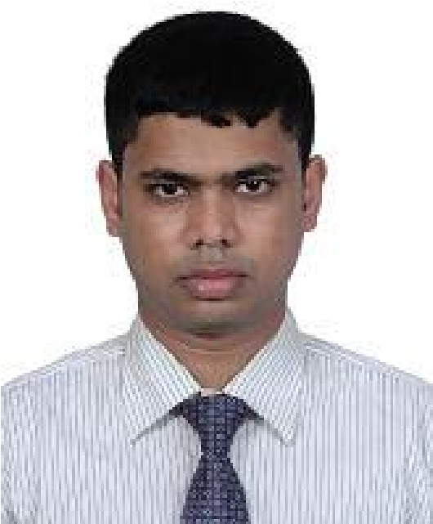Date: 22/03/2021

**SHAMS-E-ADATH**

C/O, Md. Shahadath Hossain

Assure Wisteria, Flat No. A-7, Road No. 1,

Avenue No. 1, Block B, Plot No. 86, Kalshi Main Road,

Mirpur, Sector 12, Dhaka-1216

**Cell:** +8801941684505

**E-mail:** eadath08@gmail.com

**Objective**

A motivated professional working at a renowned oil & gas company in the country is seeking scope to take new challenges where enthusiasm & professionalism can be utilized in a dynamic job environment.

**Job History (Total 4 Years):**

* Working as Senior Executive – HR & Admin at Bashundhara Oil & Gas Company Ltd. under **Bashundhara Group** since 02-Feb-2019 up to till today.

**Responsibilities:**

* + Assisting in total employee recruitment and selection process.
  + Preparing reports on expenses, office budget and other expenditures.
  + Prepared all HR & Admin related forms for smooth operation of the dept.
  + Using SAP for easing HR & Admin jobs.
  + Provide proper support to the operation team so that the process can run smoothly.
  + Prepared an organogram successfully and updating it in a professional manner.
  + Generated an overall standard operating procedure (SOP) for the department & ensuring about proper implementation.
  + Planning & control of transport, travel & accommodation management & providing support as required.
  + Ensuring proper coordination of administrative support services.
  + Developing & implementing periodical work plans.
  + Coordinating building & maintenance issues for general repair and updating.
  + Maintaining proper documentation process & storage for all HR & Admin related documents.
  + Coordinate with safety & participatory committees.
  + Ensuring good housekeeping, cleaning & hygiene matter of office premises.

* Served as a Senior Officer (**Document Controller Cum Project Admin**) at National Development Engineers Ltd. assigned to “***British American Tobacco Bangladesh Company Ltd.***” construction project since 20-Dec-2016 up to 24-Jan-2019.

**Responsibilities**:

* Keep track of budgets and project expenditures.
  + Allocating and controlling the document numbering system for the project work.
  + Support technical projects & departments.
* Planning, coordinate & participating in execution to complete the project works in time
* Handle the minute-taking at meetings.
  + Providing administrative supports and handling administrative bills for submission to management.
  + Arranging all types of supports for events to make successful.

**Academic Credentials**

|  |  |  |  |
| --- | --- | --- | --- |
| *M. Sc.* | Institution | **:** | Shahjalal University of Science & Technology, Sylhet. |
| Department | **:** | Mathematics. |
| Result | **:** | 3.23 (On Scale of 4) |
| Year | **:** | 2014 |
|  | | | |
| *B. Sc. (Hon’s)* | Institution | **:** | Shahjalal University of Science & Technology, Sylhet. |
| Department | **:** | Mathematics. |
| Result | **:** | 3.05 (On Scale of 4) |
| Year | **:** | 2013 |
|  | | | |
| *H.S.C* | Institution | **:** | Mirzapur College, Mirzapur, Tangail. |
| Board | **:** | Dhaka. |
| Group | **:** | Science. |
| Result | **:** | CGPA 4.90 (On scale 5.00). |
| Year | **:** | 2009 |
|  |  |  | |
| *S.S.C* | Institution | **:** | Mirzapur S.K. Pilot High School, Mirzapur, Tangail. |
| Board | **:** | Dhaka. |
| Group | **:** | Science. |
| Result | **:** | CGPA 4.69 (On scale 5.00) |
| Year | **:** | 2007 |

**Other Certifications:**

* Successfully completed Post Graduation Diploma (PGD) in Information Technology (IT) having CGPA 3.86 out of 4.00 from Institute of Information & Communication Technology (IICT) at Shahjalal University of Science & Technology (SUST) in 2016.
* Successfully completed the Cisco Certified Networking Associate (CCNA) from SUST Local Academy at 2013 with about 85% marks.

**Software & Professional Skills:**

Microsoft Application Package (MS Word, MS Excel, MS Power Point, MS Project), Planning, Administration, Primavera P6.

**Language Proficiency:**

* Fluently speaking and excellent writing capacity in English and Bangla.

**Interest and Achievement:**

* Champion at Inter Semester Parliamentary Debate Championship 2013
* Interested in Photography.

**Extra-Curricular Activities:**

* Worked as a Publicity Secretary from 1st January to 31st December, 2012, Treasurer from 1st January, to 31st December 2013 and Senior Vice President from 1st January to 31st December, 2014 at Mangrove Association known as a regional organization.

**Personal Information:**

Father’s Name : Md. Shahadath Hossain.

Mother’s Name : Nazma Hossain.

Permanent Address : Vill: Goshnagar, P.O: + Thana: Jiban Nagar, Dist : Chuadanga.

|  |  |
| --- | --- |
| Date of Birth | : 01/12/1992. |
| Religion | : Islam. |
| Blood Group | : B+. |
| Nationality | : Bangladeshi. |

**Reference:**

* Mst. Sheren Shobnom, Vice Secretary, Ministry of Public Administration, Government of the People’s Republic of Bangladesh, Bangladesh Secretariat, Dhaka, Bangladesh.
* Md. Salah Uddin Ahmed, Branch Operation Manager, Eastern Bank Ltd., Bhulta Branch, Narayangonj, e-mail: ahmedmsbd@gmail.com, Cell: +8801714217227.